**Documentation of Project**

**Description of how the program works.**

**Project Specification:**

We must have DOSBox 8086 Assembler to run this project.

We have to download and install DOSBox.

**Download link of DOSBox:**

<https://www.dosbox.com/download.php?main=1>

**Download TASM:**

[**https://drive.google.com/file/d/0BxFfQqBvZCltMHdNbFFCZVJkUlE/view?usp=sharing**](https://drive.google.com/file/d/0BxFfQqBvZCltMHdNbFFCZVJkUlE/view?usp=sharing)

First install the DOSBox.

Then, extract the TASM folder in C drive.

All files should be placed in C:/Tasm folder.

We have 3 files:

1. Project.asm (main procedure)
2. Lib.asm (for macros and procedures)
3. File.txt (the file to be read)

To run this project, we have to open DOSBox:

**How to run Program on DOSBox:**

Please follow these steps:

* 1. mount c c:\Tasm
  2. c: (enter)
  3. tasm project.asm
  4. tlink project
  5. project.exe (or project)

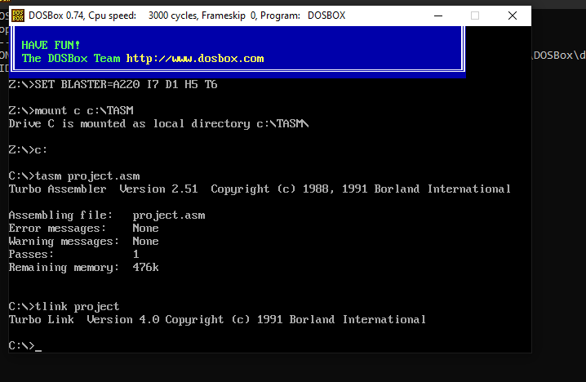

We can also pass argument to program using -h, -r and -p. like:

* + project -h (will display help)
  + project -r (display the data in reverse order)
  + project -p (display the data with paging feature)

**What kind of macros are there?**

Here is list of macros:

clearScreen ; this macro will clear the screen

setCursorAtTopLeft ; this macro set the cursor at top left position

pushAllRegisters MACRO ; this macro will push all registers on stack

popAllRegisters MACRO ; this macro will pop all registers from stack

**What kind of procedures are there?**

printHelp proc ; this proc will print help

fileReading proc ; this proc will read data from file and store in buffer array

placeEndOfFile proc ; this proc will place NULL character at buffer

displayFromStart proc ; this proc will display the file from top

countTotalPages proc ; this proc will count the total no of pages

displayWithPaging proc ; this proc will display pages with up and down (by pressing up and down arrow key)

displayFromEnd proc ; this proc will display the file from end

displayNumber proc ; this proc will display a number in decimal

findTotalSentence proc ; this proc will find total sentence in file

printNewLine proc ; this proc will print the new Line on screen

displayDetail proc ; this proc will display date and time detail

displayPageDetail proc ; this proc will display the page detail (total pages, current page, or display percentage of displayed page)

displayDate proc ; this proc will display the current date

displayTime proc ; this proc will display current time

DISP PROC ; this proc will date and time in separate digit

**What System calls are used?**

I used these systems call in my project.

Mov ah, 09h ; for display the string

int 21h

mov ah, 02h ; to print character on screen

int 21h

Mov ah, 0h ; for taking input for keys up and down

int 16h

mov ah,4ch ; for exit program

int 21h

mov ah, 3dh ; to open file in read mode

int 21h

mov ah, 3FH ; to read file

int 21h

mov ah, 2ch ; To get System Time

int 21H

mov ah,2ah ; To get System Date

int 21H

mov ah,06h ; to clear screen

mov bh,07h

int 10h

mov ah,02h ; to set cursor position

mov bh,00h

int 10h

**When macros are used.**

These macros are used in program.

clearScreen ; for clearing the console screen

setCursorAtTopLeft ; set the cursor at top left position

pushAllRegisters MACRO ; to save the contents of registers on stack

popAllRegisters MACRO ; to pop all registers contents from stack

**How command options work.**

Here is list of commands used in program.

* + project -h (will display help)

it will call displayHelp proc, this procedure uses ah, 09h system call to display help menu.

* + project -r (display the data in reverse order)

it will call displayFromEnd proc, it will display the sentences in reverse order by using index array for all sentences.

* + project -p (display the data with paging feature)

it will call displayWithPaging proc, its explanation is given at end.

**What are the command options there and how does the recognition work?**

We can also pass command line argument to program using project -h, -r and -p. like:

* + project -h (will display help)
  + project -r (display the data in reverse order)
  + project -p (display the data with paging feature)

First, I store the command line arguments in DX register using this command.

; getting command line arguments

mov si,82h ; si will store the starting byte of command line arguments

mov dh, [si] ; dh will contain ‘-‘

mov dl, [si+1] ; dl will contain ‘-h’, ‘-r’ or ‘-p’

Then, we compare the dx register content with each command.

If it contain ‘-h’, then we call displayHelp procedure.

If it contain ‘-r’, then we call displayFromEnd procedure.

If it contain ‘-p’, then we call displayWithPaging procedure.

Else, display the content of file from top. It will call displayFromStart procedure to display from top of file.

**How paging will work.**

For paging, first I found total no of pages, which will be displayed on screen. And store the page start index in pageIndexArray and line no. in pageLineIndex array.  
Then, displayWithPaging proc will display the page with up and down feature. This will start printing the sentences and stopped when cursor reach at last line of console screen. Then it will take input from user to press key, up arrow (for page up) and down arrow (page down). If user enter up arrow, then we decrement the page index, and page line no, then we clear the screen and display previous page. If user enter down arrow, then we will change the currentPageIndex to next page index to print next page and starting line of next page. Otherwise, when wrong input, no action take place. When we reach last page then program will stop. ­